C++

This is an object-oriented extension to C, developed at AT&T Labs by Bjarne Stroustrup. The central idea is to give a programmer the ability to define classes from which objects can be instantiated. C++ provides some support for true object-orientation, that include class definition, object instantiation, inheritance (single and multiple), message passing and encapsulation.

In contrast to other object-oriented languages such as CLOS and Smalltalk, classes in C++ can not be defined dynamically, only at compilation time. For very sophisticated projects, or for projects requiring simulation, this could be a serious shortcoming. It seems, however, that for most people, the absence of this feature is not crucial.

C++ supports

+ Classes, instances, and methods
+ Polymorphism, encapsulation, and inheritance

C++ does not support

- Automatic garbage collection
- dynamic creation of classes

The main forte of C++ is code reuse and encapsulation. Since most modern programming enterprises involve thousands of lines of code, these features have given C++ its popularity, and, to many, the language constitutes the last "... piece of wood to hang in the middle of the ocean ..."

The following points will be covered for C++:

• Programming Style in C++ (differences between C and C++)
• C++ enhancements over C.
• References and their relation to pointers
• Classes
• Memory Allocation
• More features of classes (static members, friends, arrays of instances, new and delete operators)
• Inheritance, polymorphism, virtual functions
• Operator overloading
- Templates
- Run Time Exception Handling

Programming style in C++ and
C++ Enhancements to "C"

C++ is a superset of C. Therefore, C++ programs look very much like "C" programs. There are however, certain fundamental differences, some of which are covered in this section.

C++ defines the following reserved words:

asm | auto | break | case | char
class | const | continue | default | delete
do | double | else | enum | extern
float | for | friend | goto | if
inline | int | long | new | operator
overload | public | register | return | short
sizeof | static | struct | switch | this
typedef | union | unsigned | virtual | void
while | signed | volatile | protected | private
try | operator | template | throw | catch

Comments

A program in C++ recognizes C-style comments /* ... */ as well as C++ comments, defined as //

// text is ignored up to the end of line.

A First Look at I/O Streams

Input/output operations in "C" are unnecessarily complicated. C++ recognizes the printf and scanf family of functions, and it also provides enhanced i/o operations through new stream operators defined in the file iostream.h. The standard streams for input, output, and error are named, respectively, cin, cout, and cerr. You can use these streams with the following operators:

<< (the insertion, or put-into operator),
>> (the get-from operator)

example:

#include <iostream.h>

/* You can write "C" comments */
// or C++ comments
main()
{
int i;
cout << "This is output \n";
cout << "enter a number : ";
cin >> i;

// now, output the number
cout << i << " the number squared is " << i*i << "\n";

return 0;
Combining "C" with C++

Code previously compiled in "C" can be given to C++ compilers, using linkage specifications. This is done with the keyword extern "C". This feature is most useful when you have access to a library of "C" functions, but not to the original source code, or in situations when you do not want to touch the "C" code.

Extern "C"  {  #include "whatever.h"  } | extern "C" int cmpStrgs(char *, char*);  void main ( )  {  . . . .  tra la la la  . . .  cmpStrgs(a,b);  } | extern "C"  {  int cmpStrgs(char *a, char *b)  {  return strcmp( a, b);  }  }

Note the use of extra parentheses. Pascal style parameter passing can also be provided, using

extern type pascal functionName( Args );

Pascal argument-passing works as follows: The parameters are pushed into the stack in order (first parameter first, etc.), and the called function cleans up the stack.

A First Look at Function Overloading

cin, and cout, are new operators defined in iostream.h. However, >> and << are operators already defined in "C" for other purposes, namely, for arithmetic shift. C++ can give these and other operators different meanings through the concept of overloading which gives the operators a meaning based on the type to which they apply. For example, << means output with streams, but left shift with numbers.

Declaring local variables

In C++ you may declare local variables anywhere in a block, not just in the beginning of it. Although this practice is supposed to help visualizing code, I do not recommend it. Obviously, the following are errors:

if ( int i == 0) { . . . } while (int i == 0 ) { . . . }

because hopefully the variable i will be successfully initialized all times.

// EXAMPLE 1  #include "iostream.h"  main ()  {  float f;  double d;  cout << "Enter 2 floats ";  cin >> f >> d;  cout << " Enter a string ";  char str[80];  cin >> str;  cout << f << " " << d << " " << str;  return 0;  } | // EXAMPLE 2  #include "iostream.h"  main ()  {  float a[100];  int n;  cout << "Enter Size";  cin >> n;  for ( int i=0; i < n; i++) {  cout << i << " ";  cin >> a[i];  cout << "\n";  }  return 0;  }

Scope Resolution

Having local and global variables introduces the problem of defining the scope of the variables. In most languages, "C" included, the general rule is that local variables have precedence over global ones.

C++ provides a scope resolution operator ::

With it, local variable names can be distinguished from global names.

Example:

int g = 9.81; // gravity in mts/sec

void main ()
{
int g = 3.27; // gravity at the moon
char origin;

cout << "Please enter your origin [E = Earth, M=Moon] ";
cin >> origin;
cout << "The gravity at your location is: ";

if (origin == 'M')
cout << g; // print the local variable
else
cout << ::g; // print the global variable
}

The need for scope resolution derived from the requirement of having name spaces, used to recognize function having synonym names, but belonging to different classes.
Function Prototypes

"C" does not require functions to be declared before being defined. C++, on the other hand, requires function declarations whenever a function is to be used in a file different from the file that defined the function. This is done using function prototypes, which need to indicate the function returning type, the function name, and the type(s) of the function arguments. Examples:

int hasName (const class Object&, void *);
int hasNodeNumber (const class Object&, void *);
int hasbbnLinkNumber (const class Object&, void *);
int returnNodeDegree (bbnNode *, Set *, bbnSet *);

bbnStack *makebbnStack(char *);
bbnNode *makebbnNode (char *);

It is a standard practice to write function prototypes after the #include definitions. The function definition will be somewhere in the body of the file, as in:

/*++
int returnNodeDegree (bbnNode *ArgObj,
Set *ArgSet, bbnSet *ArgLinks)

FILENAME: bbnfns.cpp
Returns the number of links that exist in ArgLinks for ArgObj with {ArgSet}. {ArgLinks} is a set containing links describing how the nodes in the ArgSet are connected.
--*/

int returnNodeDegree (bbnNode *ArgObj, Set *ArgSet, bbnSet *ArgLinks)
{
int isResult = 0;
bbnLink *NewLink;

if (ArgSet->isEmpty())
return isResult;
if (ArgLinks->isEmpty())
return isResult;
for (int i=0; i<ArgObj->getNodesCount(); i++) {
NewLink = returnUnDirLink (ArgObj, ArgObj->Nodes[i]);
if (ArgLinks->hasLinkWithSameItemsUnDir((bbnLink *)NewLink))
isResult++;
}

delete NewLink;
return isResult;
} // end of returnNodeDegree

/*++
hasName(const class Object &LocObj, void *p)
FILENAME: bbnfns.cpp

This function is to be used with container objects having
a slot Name. The function is a testFunction that can be
given to the firstThat and lastThat function members of
the container. The function should be used as follows:
*n2p = (bbnNode &) s1p->lastThat (hasName, "Bag");
where n2p is an Object-derived non-container class,
and s1p is a pointer to an Object-derived container.
--*/

int hasName(const class Object &LocObj, void *p)
{

if (!( strcmp( ((bbnNode &)LocObj).Name, (char *) p)))
return True;
else
return False;
}

Note the use of const. It tells the compiler to treat the reference to LocObj as a read-only region in memory.
Default Function Arguments

If arguments are omitted from a function call, C++ uses default values (if given), to cover the absent arguments. When function calls are made, arguments can be omitted only if they are situated at the right of the last argument included in the function call.

Function Prototype:

void findVol (int i=10; float f = 3.1426; double d = 123.123);

Function calls:

findVol(123, 123.123, 345.986);
findVol(6); // equiv. to findVol(6, 3.1416, 123.123);
findVol( ); // equiv. to findVol( 10, 3.1426, 123.123);

Inline Functions

Inline functions are macro-expanded during compilation. Unlike the older #define macros, which are only a simple text translation at pre-compile time, inline functions parameters are checked by the compilers.

The use of inline functions is recommended only with functions having small pieces of code, or with time-critical functions, because the code will be inserted wherever it is called up.

Inline functions can be defined inside a class declaration, or anywhere in a file.

Restrictions: can not contain static data, can not contain loop statements (for, while, etc.,) can not have return if type is void.

Inline functions do not have the undesirable side effects of the #define macro substitution. Example:

// the lines below were taken from stdlib.h
#define MAX(a,b) (((a) > (b)) ? (a) : (b))
#define MIN(a,b) (((a) < (b)) ? (a) : (b))

inline int max (int a, int b)
{
if (a > b) return a;
return b;
}

void main ()
{
int x,y,z;

x = 10; y=20;
z=MAX( x++, y++); // larger value incremented twice
cout << "x= " << x << " y=" << y << " z=" << z; cout << endl;

x = 10; y=20;
z=max( x++, y++); // do not change arguments
cout << "x= " << x << " y=" << y << " z=" << z; cout << endl;
}

The output of this program is:

X = 11 Y = 22 Z = 21
X = 11 Y = 21 Z = 20

because the macro MAX evaluates Y++ twice, but a value is returned, then ++ is evaluated (in MAX). The inline max evaluates both arguments once, which is more attuned with the rationale of the code.
References

References are a new type of variable introduced by C++. References are mainly used to pass parameters to functions and to return values from them.

A reference is not a copy of the variable to which the reference is made. Instead, it is the same variable, disguised with a different name.

In contrast to pointers, once a reference is associated to a variable, that association stays permanently (within the block where the association was made).

References are defined using the unary operator &

int value = 100;
int &refValue = value;

value++;
refValue++;
// both, value and refValue have 102.

The address of the memory region being referenced is the same for both names:

cout << &value <<' '<< &refValue; //should be the same

References as Function Parameters

References can be used to pass arguments between functions in a call-by-reference style (by default, C and C++ pass arguments using call-by-value).

Example:

// call-by-reference pointer  void negate(int *i);  main()  {  int x;  x = 123;  cout << x << " negated is ";  negate(&x);  cout << x << "\n";  return 0;  }  void negate(int *i)  {  *i = -*i;  } | // call-by-reference using reference  void negate(int &i);  main()  {  int x;  x = 1230;  cout << x << "negated is ";  negate(x);  cout << x << "\n";  return 0;  }  void negate(int &i)  {  i = -i; // don't need *  }

References as Function
Parameters Having Structures

References can also by used to pass object parameters. This will be covered in conjunction with classes. For the time being, we will see how they can be used with structures.

struct MyStr {
int number;
char text[512000];
} Lofas = {41, "Allegro"};

void passVal( MyStr ArgVal);
void passPtr( const MyStr *ArgPtr);
void passRef( const MyStr &ArgRef);

void main ( )
{
passVal ( Lofas );
passPtr ( &Lofas );
passRef ( Lofas );
}

void passVal ( MyStr Var)
{
int i;
i = Var.number;
}

void passPtr ( const MyStr *Var)
{
int i;
i = Var->number;
}

void passRef ( const MyStr &Var)
{
int i;
i = Var.number;
}

passVal is inefficient, because a copy of Lofas, with the 512000 chars of text[], will be assigned to Var. passPtr and passRef remedy that because only the address of Lofas is passed, not the entire contents.

However note that the syntax of passRef is less demanding than that of passPtr. Also note the use of const in passRef, to indicate that the called functions are not supposed to modify the argument.

passRef is the preferred solution because it passes the address, saving time and space, and you have the option of declaring read-only (with const) of read-write.
Polymorphism in C++

Polymorphism means that a function name can have more than one body. Polymorphism cam be done in C++ using three methods: overloading (function and operator), name hiding, and inheritance.

Function overloading: It means that two or more functions can share the same name, as long as the parameter declarations are different. For example, in "C" you need different functions for abs, according to the type of number you deal with ( abs(), labs(), fabs() ). In C++ you only need one:
Function overloading also occurs when the same function signature is used in derived classes, as in:

class A { int f1(int,float);}

class B :public A { int f1(int, float); }
Operator Overloading

When an operator is overloaded, it takes an additional meaning relative to the specified type; at the same time, the operator keeps its old meaning for the original types. In C++, you can overload all the old "C" operators (like <<, >>).

Inheritance

With inheritance, hierarchies of classes can be built, from the most general to the most specific. First a base class, having all the features and operations common to the most basic objects is defined, and from this class, more specific, or specialized classes are derived.
class newClassname: access baseClass
{
// body of class
};
Public
Protected
Private

class building { | // house is derived from building
int rooms | class house :public building {
int floors; | int bedrooms;
int area; | int baths;
public: | public:
void set_rooms(int num); | void set_bedrooms (int num);
int get_rooms(); | int get_bedrooms();
void set_floors(int num); | void set_baths(int num);
int get_floors(); | int get_baths();
void set_area(int num); | };
int get_area();
};

C++ Classes

Classes are user-defined types for which you can define composition and function. A class may contain private, protected, and public parts defining the composition (data members) or the function (function members and operators).

By default, all parts in a class are private.

Private parts can not be accessed by any function that is not a member of the class. Protected parts are accessible to function members of derived classes and their friends.

Structures versus classes

Syntactically, classes are similar to structures. Expanding this analogy, we may say that variables can be seen as instantiations of structures while objects can be considered instantiations of classes.

There are several differences between structures and classes.

1. Not having the concept of access control, access to the data members of a "C" structure is by default public. In C++ you can control access to structure data members for structures, by using the keywords private, protected, public. Note also that the defaulted access to members of a C++ class is private.

2. Although it is possible to associate functions to structures, class methods provide a cleaner mechanism.

3. Structures can't evolve as easily as classes can (in the sense of inheritance), nor can they define access methods for derived members (protected).
Unions versus classes

A union in C++ retains the "C" property dictating that all data elements share the same location in memory.

C++ unions can have data and function members, including constructors and destructors.

C++ unions can have access control. By default, union members are public, but you can use the access keywords (private, protected) to change the access control as in classes.

The general form of a union declaration is:

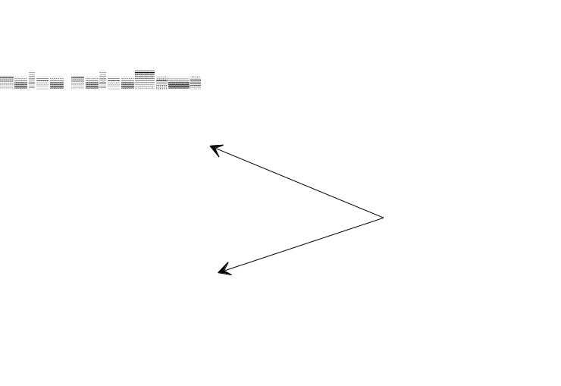

The similarity with classes ends there. In fact, C++ imposes a number of restrictions to unions:

• Unions can neither have inheritance, nor serve as base classes.
• Unions can't have virtual functions.
• Unions can not have static data members
• Unions can't overload the = (assignment) operator
Example:
(Note resolution operators and instances)
#include "iostream.h"  const int SIZE =100;  // define the class stack  class stack {  int stck[SIZE];  int tos;  public:  void init();  void push(int i);  int pop(void);  };  void stack::init()  {  tos = 0;  }  void stack::push(int i)  {  if(tos==SIZE) {  cout << "stack is full";  return;  }  stck[tos] = i;  tos++;  }  int stack::pop()  {  if(tos==0) {  cout << "stack underflow";  return 0;  }  tos--;  return stck[tos];  } | main()  {  // instantiate objects  stack stack1, stack2;  // pass msgs to objs  stack1.init();  stack2.init();  stack1.push(1);  stack2.push(2);  stack1.push(3);  stack2.push(4);  cout << stack1.pop() << " ";  cout << stack1.pop() << " ";  cout << stack2.pop() << " ";  cout << stack2.pop() << "\n";  return 0;  }  Question:  What would happen if, in main, we include a statement like:  stack1.tos = 0;  Answer:  error, because tos is a private data member in stack, not visible from main.
Constructors and destructors
Since it is very common to initialize and destroy objects, C++ offers functions that automatically do these operations. A constructor function is a member function of the class, and has the same name as the class name. Similarly, a destructor is a member function of the class, with a name specified as the name of the class, preceded by tilde (~). Constructors and destructors can have other code too:

#include "iostream.h"  const int SIZE =100;  // define class stack  class stack {  int elemArray[SIZE];  int elemCounter;  public:  stack(); // constructor  ~stack(); // destructor  void push(int i);  int pop();  void init();  void printElementsCount();  int getElementsCount();  };  // stack constructor  stack::stack()  {  elemCounter = 0;  cout << "stack constructed\n";  }  // stack destructor  stack::~stack()  {  cout << "stack destroyed\n";  }  int stack::getElementsCount()  {  return elemCounter;  } | void stack::init()  {  elemCounter = 0;  cout << "stack initialized\n";  }  void stack::push(int i)  {  if(elemCounter==SIZE) {  cout << "stack is full";  return;  }  elemArray[elemCounter] = i;  elemCounter++;  }  int stack::pop()  {  if(elemCounter==0) {  cout << "stack underflow";  return 0;  }  elemCounter--;  return elemArray[elemCounter];  }  void stack::printElementsCount()  {  cout << "stack has" ;  cout << elemCounter;  cout << " elements ";  }
main()
{
// create two stack instances
stack a, b;

a.push(1);
b.push(2);

a.push(3);
b.push(4);

cout << a.pop() << " ";
cout << a.pop() << " ";
cout << b.pop() << " ";
cout << b.pop() << "\n";

return 0;
}

By default, before termination of its execution, a program calls the destructor of each class, to destroy the objects that were instantiated during execution.
Friends

The friend keyword can be used with classes or functions, to signify that the friend function, or fiend class, has access to all private and protected members of the class for which the function or class is a friend. Note that a friend function is not a member function of a class. Friend functions are announced by a keyword placed in front of the function declaration. Friend functions can access more than one class.

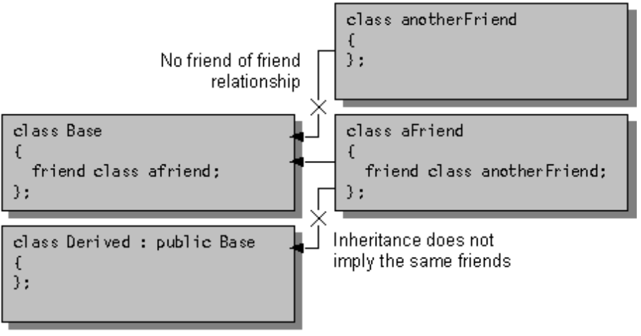

The following program illustrate polling a common resource:

#include "iostream.h"  const int IDLE = 0;  const int INUSE =1;  // forward reference  class C2;  class C1 {  int status; // IDLE | INUSE  public:  void set_status(int state);  friend int idle(C1 a, C2 b);  };  class C2 {  int status; // IDLE | INUSE  public:  void set_status(int state);  friend int idle(C1 a, C2 b);  };  void C1::set_status(int state)  { status = state; }  void C2::set_status(int state)  { status = state; } | int idle(C1 a, C2 b)  {  if ! ( a.status || b.status) return IDLE;  else return INUSE;  }  main()  {  C1 x;  C2 y;  x.set_status(IDLE);  y.set_status(IDLE);  if( idle(x, y) == IDLE) cout << "resource available\n";  else cout << "resource busy\n";  x.set_status(INUSE);  if(idle(x, y)) cout << "resource available\n";  else cout << "resource busy\n";  return 0;  }

A Complete Example

Suppose you want to write a computer program for keeping track of the various kinds of vehicles owned by your transportation company, known as "El Huarache Veloz." The hierarchy below defines the kinds of vehicles you have:

We would like our classes
to have the following attributes:

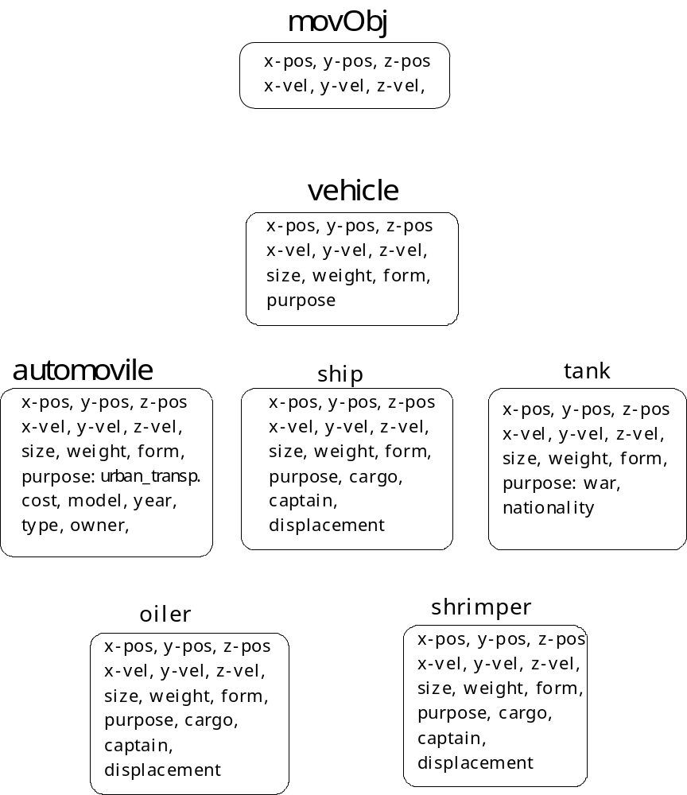
MovObj in C++

#include "iostream.h"
const SIZE = 100;

class MovObj {

private:
int id;

public:
float xPos, yPos, zPos;
float xVel, yVel, zVel;

MovObj(int argID=0)
{
cout << endl << "Executing MovObj constructor" << endl;
id = argID;
xPos = 0.0; yPos = 0.0; zPos = 0.0;
xVel = 0.0; yVel = 0.0; zVel = 0.0;
}

~MovObj ()
{
cout << endl << "Destroying a MovObj " << endl;
}

void setPos (float x=0.0, float y=0.0, float z=0.0)
{
xPos = x; yPos = y; zPos = z;
}

void setVel (float x=0.0, float y=0.0, float z=0.0)
{
xVel = x; yVel = y; zVel = z;
}

void prt()
{
cout << " \n ID= " << id ;
cout << endl;
cout << "xPos= " << xPos << " yPos= " << yPos << " zPos= " << zPos;
cout << endl;
cout << "xVel= " << xVel << " yVel= " << yVel << " zVel= " << zVel;
cout << endl;
}

int EqualId (const MovObj &o2)
{
return (id == o2.id);
}

int EqualPos (const MovObj &o2)
{
return (( xPos == o2.xPos) &&
( yPos == o2.yPos) &&
( zPos == o2.zPos));
}

int EqualVel (const MovObj &o2)
{
return (( xVel == o2.xVel) &&
( yVel == o2.yVel) &&
( zVel == o2.zVel));
}

int isEqual ( const MovObj & o2)
{
return ( ( EqualId (o2) ) &&
( EqualPos (o2) ) &&
( EqualVel (o2) ) );

}

}; // This ends the classDef of MovObj

main ()
{
MovObj m1, m2(1), m3;
MovObj *p1, *p2;

cout << "Print 1 if objs are equal " << m1.isEqual(m3) << "\n" ;

m1.prt();
m1.setPos (1.0, 2.0); m1.setVel (10.0, 20.0, 30.0);
m1.prt();

m2.prt();

cout << "print 1 if objs are equal " << m2.isEqual(m1) << "\n" ;

}

EXECUTING WE GET

Executing MovObj constructor
Executing MovObj constructor
Executing MovObj constructor

Print 1 if objs are equal 1

ID= 0
xPos= 0 yPos= 0 zPos= 0
xVel= 0 yVel= 0 zVel= 0

ID= 0
xPos= 1 yPos= 2 zPos= 0
xVel= 10 yVel= 20 zVel= 30

ID= 1
xPos= 0 yPos= 0 zPos= 0
xVel= 0 yVel= 0 zVel= 0
print 1 if objs are equal 0

Destroying a MovObj
Destroying a MovObj
Destroying a MovObj

Now let's define the rest of the classes:

class Vehicle : public MovObj {

public:
int size;
int weigth;
char purpose[40];

Vehicle (char *ArgPurpose = "lofas" )
{
strcpy(purpose, ArgPurpose);
}

}; //end of Vehicle Class Def

class Automovile :public Vehicle {

public:
float cost;
int year;
char owner[80];
char type[80];
char model[80];

Automovile (char *ArgPurpose = "Urban Transportation" )
{
strcpy (purpose, ArgPurpose);

}

}; // end of Vehicle Class def

class Ship :public Vehicle {

public:
char cargo[80];
char captain[80];
float displacement;

}; // end of Ship Class Def

class Tank :public Vehicle {

public:

Tank (char *ArgPurpose = "WAR" )
{
strcpy (purpose, ArgPurpose);
}

}; // end of Tank Class def

class Oiler :public Ship {

public:

Oiler ()
{
char *LocPurpose = "Transport Oil";
char *LocCargo = "Oil";

strcpy (purpose, LocPurpose);
strcpy (cargo, LocCargo);

}

}; //end of Class Oiler

class Shrimper :public Ship {

}; //end of Class Shrimper

main ()
{

if (!out) {
cout << "Can not open test file \n";
return 1;
}

Vehicle v1;
Automovile a1;
Tank t1;
Ship sh1;
Oiler o1;
Shrimper sr1;

v1.prt();
a1.prt();

EXECUTING THE CODE ABOVE:

Executing MovObj constructor
Executing MovObj constructor
Executing MovObj constructor
Executing MovObj constructor
Executing MovObj constructor
Executing MovObj constructor

ID= 0
xPos= 0 yPos= 0 zPos= 0
xVel= 0 yVel= 0 zVel= 0

ID= 0
xPos= 0 yPos= 0 zPos= 0
xVel= 0 yVel= 0 zVel= 0

Destroying a MovObj
Destroying a MovObj
Destroying a MovObj
Destroying a MovObj
Destroying a MovObj
Destroying a MovObj

Now suppose we define prt for Oilers as in:

oiler::prt ()
{
MovObj::prt();
out << purpose << "... " << cargo << "\n";

}

The output for o1.prt() will look like:

ID= 0
xPos= 0 yPos= 0 zPos= 0
xVel= 0 yVel= 0 zVel= 0
Transport Oil... Oil

Pointers to Class Objects

Pointers can be used to point to areas in memory occupied by class instantiations (objects). The syntactic usage is the same as in "C":

class c1 {
public:
int a;
};

main ()
{
int b;
c1 Obj1,Obj2,*pObj; // Obj1, Obj2 are objects of class c1,
// pObj is a pointer to c1 objects

Obj1.a = 1000;
pObj = &Obj1; // pObj now has the address of Obj1;
Obj2.a = pObj->a;
};

At the end of this program, pObj still points to Obj1. Obj2 received, via pObj, the value stored at Obj1.a.
Function Members and this pointer

C++ provides a special pointer that can be used to locate class data members within class function members. The pointer is denoted this. The pointer this is passed automatically to class function members, where it could be used if needed.

Val = be

class power {
int e; // note, e,b,val are all private
double b;
double val;

public:

power(double base, int exp=2)
{
val=1; b=base; e=exp;
for (; exp>0; exp--) val=val*b;
}

double get_power()

{
return val;
}

}; //EOC power

The function power could have been written as follows:

power(double base, int exp=2)
{
this->val=1; this->b=base; this->e=exp;
for (; exp>0; exp--)
this->val=this->val*this->b;
};

i.e., this is the pointer given to the function when called. As any other syntactic sugar construct, usage of the this pointer is not encouraged.

Remember what Perlis said:

". . . syntactic sugar causes cancer of the semicolon . . "

The message is: avoid unnecessary stuff

Back to our example. A call to power could be:

main ()
double x1, x2, x1a;
power p1(12), p2(12,3), *pp3;

pp3 = &p1;
x1 = p1.get_power();
x2 = p2.get_power();
x1a = pp3->get_power();
};

Pointers to Derived Classes

Let's look at the movObj class hierarchy again:

Now suppose you have the following main:

main ()
{

MovObj m1, *pmo;
Vehicle v1, *pVe;
Automovile a1;
Tank t1; Ship sh1;
Oiler o1; Shrimper sr1;

m1.setPos(2,3,4);
v1.setPos(1,2,3); a1.setPos(2,3,4);
t1.setPos(3,4,5); o1.setPos(4,5,6);
sh1.setPos(7,8,9); sr1.setPos(5,6,7);

pmo = &m1; pmo->prt(); //gets movObj::prt
pmo = &v1; pmo->prt(); //gets vehicle::prt (if any)
pmo = &t1; pmo->prt(); //etc...
pmo = &o1; pmo->prt(); //etc....
// etc...

pVe = &v1; pVe->prt() // calls vehicle::prt() (if any)
pVe = &o1; pVe->prt() // calls oiler::prt() (if any)
};

Since pmo is a pointer rooted at MovObj, it can be used to navigate through the entire hierarchy, as illustrated above.

Summary of Access Control

(see Chapter 11, Ellis & Stroustrup)

A. Access to Members

1. Classes have a name, data members, function members, operators, ancestors classes and derived classes.

2. Members of a class can be private, protected, or public.

3. Unless otherwise specified, all members of a class are private by default.

4. If access is private, then only function members of the class and their friend functions have access to the name of the member.

5. If access is protected, then the name of the member can be seen by function members of the class and its friend functions, as well as the function members of the derived classes and their friend functions.

6. Public means that access is not restricted.

7. Access can be controlled by explicit use of the keywords private, protected, public.

B. Access to Base Classes
(See also Ch11, Ellis & Stroustrup)

1. A base class can be declared as being private, protected, or public.
2. Access to the members and friends of the base class are affected by the way the derived class is connected to the base.

Classes are derived according to the general form:

class derived-class-name : access-specifier base-class-name {
// body of the class
};

Access-specifier can be either public, protected, or private (default).

When the access-specifier is public, the base class members are inherited as-is, i.e., all public members of the base class become public members of the derived class, and all the protected members of the base class become protected in the derived class.

C++ passes private members in the base class to the derived classes. These members are private at the base and therefore are not visible at the derived classes. Obviously, it does not make sense to inherit members you can't see, but that is the way the C++ implements protection. Nevertheless, you can access private members in base classes via public members functions at the base class. Hence, although private data members of base class are in fact inherited, not having direct access to them in the derived class has the desired effect of putting a blanket with hooks (accessors) around them.

When the base class is derived using private as the access-specifier, then all public and protected members of the base class become private members in the derived class. In summary:

Base Class (BC) | inherited as | In Derived Class is:
priv, pro, pub | private | Pub,pro->private, priv-> no access
priv, pro, pub | protected | Pub,pro->protected, priv-> no access
priv, pro, pub | public | Pub->public, pro->protected, priv->no access

class Xbase {
public:
int a;
}
class Ypub : public Xbase { } ;
class Ypro : protected Xbase { } ;
class Ypri : private Xbase { } ;

void f1 ( Ypub* py1, Ypro* py2, Ypri* py3)
{
Xbase* px= py1; //OK
py1->a = 123; // OK, access to Xbase via yPub is public
px = py2; // error, access to Xbase via yPro is protected
py2->a = 234; // error occurs because f1 is out of scope
px = py3; //error, access to Xbase via yPri is private
py3->a = 123; //error
}

Now add class zPub and zPro as in

class zPub : public Ypro { void f1 (...); };
class zPro : protected Xbase { };

void zPub::f1(yPub* py1, yPro* py2, yPri* py3)
{
Xbase* px = py1; // OK access via xBase is public
py1->a = 123; // OK

px = py2; // OK, xBase is a protected base for yPro
// and for zPub
py2->a = 123; // OK. Access due to inheritance

px = py3; // error: xBase is private for yPri
py3->a = 123; //error
}

Finally:

class Ypri_A : private Xbase { void ff(); } ;

void Ypri_A::ff(yPub* py1, yPro* py2, yPri_A* yp3)
{
XBase* px = py1; //OK
py1->a = 123; //ok

px = py2; //error

py2->a = 123; // error (book is wrong)
px = py3; // OK
py3->a = 123; OK
}

A Second Look at I/O Streams
(See also Chapter 10, of “The C++ Programming reference,” Second Edition, by Biarne Stroustrup )

C++ programs have four default streams:

cin | cout | cerr | clog

These streams are included in your program issuing:

#include <iostream.h>

Streams use the insertion and get-from operator:

<< | insertion operator
>> | get-from operator

C++ in fact creates an object-oriented hierarchy for stream operations that has the following structure:

One way of doing formatted I/O is by manipulating the members of the IOS class. This class has several status flags which can be set or cleared.

The second method for formatting I/O is the use of manipulators.

FORMATTING with IOS

// formatting flags for Borland C++ 4.0:
enum {
skipws = 0x0001, // skip whitespace on input
left = 0x0002, // left-adjust output
right = 0x0004, // right-adjust output
internal = 0x0008, // padding after sign or base indicator
dec = 0x0010, // decimal conversion
oct = 0x0020, // octal conversion
hex = 0x0040, // hexadecimal conversion
showbase = 0x0080, // use base indicator on output
showpoint = 0x0100, // force decimal point (floating output)
uppercase = 0x0200, // upper-case hex output
showpos = 0x0400, // add '+' to positive integers
scientific= 0x0800, // use 1.2345E2 floating notation
fixed = 0x1000, // use 123.45 floating notation
unitbuf = 0x2000, // flush all streams after insertion
stdio = 0x4000 // flush stdout, stderr after insertion
};

Examining the Formatting Flags

The class IOS has several member functions of interest: setf(), unsetf(), flags(), width(), precision(), and fill().

The function flags(), without arguments, returns the current setting of each format flag, encoded as a long int:

long flags()

flags() can also be used with a long argument, to set a bit mask that sets or clears certain flags.

long flags (long argFlags)
Modifying the Formatting Flags

The formatting flags can be set with the function

long setf (long argFlags);

The function setf() returns the previous settings of the flags and turns those flags according to the argFlags specification. Only the flags specified in argFlags are affected. Examples:

stream.setf(ios::showpos);
stream.setf(ios::hex | ios:showbase); stream << 100; //shows 0x64

Note the use of the OR operator to specify more than one flag.

The flags can be cleared with the function

long unsetf (long argFlags);

The previous flags settings are returned. Only the flags included in the argFlags argument expression are affected. Examples:

cout.setf(ios::uppercase | ios::scientific);
cout << 100.12; // displays 1.0012E+02

cout.unsetf(ios::uppercase); //clears uppercase flag
cout << "\n" << 100; // displays 1.00e+02

Using width(), precision(), and fill()

Formatting involves manipulating the width and the precision of numerical operands, and how filling characters will be used.

By default a number is written using as many characters as needed. However, the minimum field can be reset with width().

int width (int argW)

By default, six digits are displayed after the decimal point. The function precision() can change this number:

int precision (int argP)

By default, the blank space is used for filling. This can be changed by the function fill():

char fill (char argCh)

main ()
{ ]
cout.precision(D2);
cout.width(10);

cout << 10.123455; //displays "10.12"
cout.fill("#");
cout<< 10.12345; //displays "#####10.12"
cout << "Hi!"; //displays "#######Hi!"
cout.setf(ios::left);
cout <<10.12345; //displays "10.12#####"
}

FILE /IO

C++ opens files by linking them to file streams. These streams are included by issuing the line below in your programs:

#include <fstream.h>

There are three types of streams:

ifstream inStream; //input
ofstream outStream; //output
fstream ioStream; // both ways

First the appropriate stream is created. Then the stream is associated to a file, using the function open().

void open (char *fileName, int access, int mode)

Mode is one of the following:

// stream operation mode for Borland's C++ 4.0
enum open_mode {
in = 0x01, // open for reading
out = 0x02, // open for writing
ate = 0x04, // seek to eof upon original open
app = 0x08, // append mode: all additions at eof
trunc = 0x10, // truncate file if already exists
nocreate = 0x20, // open fails if file doesn't exist
noreplace= 0x40, // open fails if file already exists
binary = 0x80 // binary (not text) file
};

Access is one of the following (in Borland C++ 4.0)

O_WRONLY
O_RDWR
O_RDONLY
O_WRONLY
O_RDWR
O_ACCMODE

/* Flag values for open only */

O_CREAT /* create and open file */
O_TRUNC /* open with truncation */
O_EXCL /* exclusive open */

However, you will rarely use access or mode. Most of the time you will issue open as in:

ofstream myOutStream;
myOutStream.open("chiquita"); // file chiquita is open for output

ifstream myInStream;
myInStream.open("bonita");// file bonita is open for input.

The function close closes the stream:

myOutStream.close();

