Introduction
Welcome to the world of Microsoft’s Visual Studio. This is the sixth edition of this tool and it has added some features that the University hopes will improve its students coding ability. This tutorial is designed to help you understand these tools and the environment in which they exist. It will walk you through the process of building a program and cover some of the added functionality that will make you a better programmer.

The first step
The first step in building a program is to start the application that you will write the program in. If the icon shown in Figure 1 exists on the desktop, double click it (if you are doing the web-style desktop, you will only have to single click).
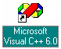
Figure 1. Icon for Visual Studio 6

If this icon does not appear, you can still start the program by clicking Start->Programs->Microsoft Visual Studio 6.0->Microsoft Visual C++ 6.0. If you have successfully performed one of these operations, a dialog box will appear identifying the program. Then a screen similar to the one shown in Figure 2 will appear.
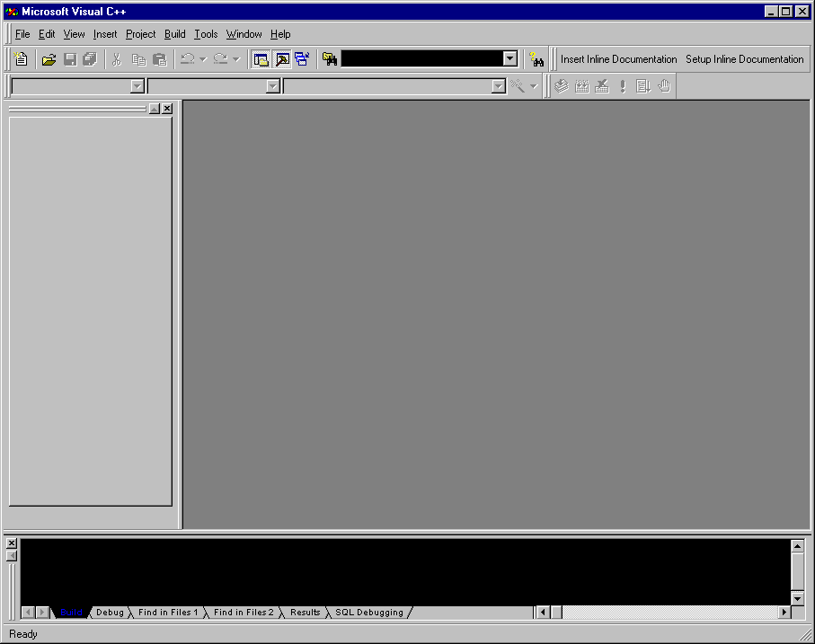
Figure 2. Initial Screen for Visual Studio 6.0.

Building an application
Congratulations, the first step is completed! Now to begin making your program, you first need to create a project. This is done by clicking File->New. A dialog box similar to Figure 3 should appear listing all the different projects you can create (for the 352 class we will only use the console apps).

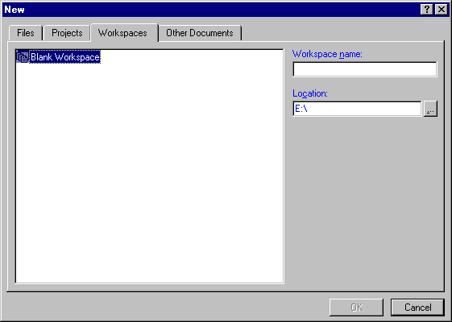
Figure 3. New dialog box.

Select which directory you wish to place your project from the button with the 3 dots next to the Location field. Then type the name of your project in the Project name field. The name will be appended to the Location field and a subdirectory will be created in the Location directory that will contain all the project data. You will notice there are four tabs in the dialog box. These are used to add other files, create a new workspace, create a readme file, etc. They will be discussed as needed.

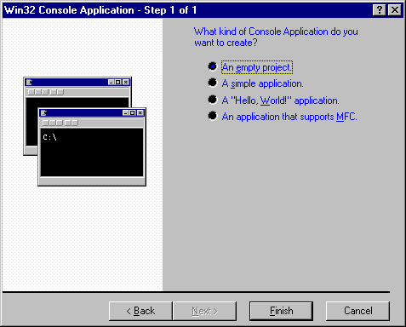
Upon pressing the OK button, another dialog box similar to the one in Figure 4 will appear.
Figure 4. Console app dialog box.

This dialog box is used to determine what type of console app you wish to create. For the most part we will probably use the second option, “A simple application.” Click this option, and press Finish. You will be prompted as to the specifications of the project. Press OK when you are finished reading.

Understanding the Environment
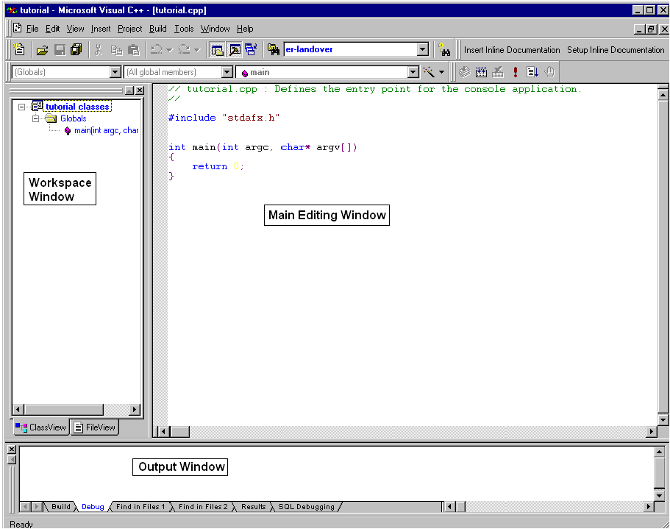At this point the screen will become one similar to the one shown in Figure 5.

Figure 5. Initial screen of Visual 6.

Please do not be intimidated by the view you see; it isn’t hard to master. The menu shown in Figure 6 is standard for the most part.
Figure 6. Visual Studio 6 Menu.
However, there are some options that are worth mentioning. If you desire to see nothing except for the code you are creating, there is a full screen option in the View menu. From this same menu you can access the other windows shown. Insert allows you to create new classes, resources (if using MFC), etc. Project will contain all the options used to customize your project. The options more commonly used will be discussed shortly. Build is the menu one will refer to when it is time to test the application. (I haven’t really used the Tools menu except to change the colors of my windows and text, both done on the Format tab of the dialog box that appears when Tools->Options… is selected.) The only other thing I have needed to do from this menu was to install the Personal Assistant tool. This tool is required for this course. Please check the Add-ins and Macros Tab from the dialog box that appears when Tools->Customize… is selected and make sure there is a check mark next to the entry for Personal Assistant Developer Studio Addin. The Window menu is used to keep track of all the windows in the Developer Studio program. The Help menu is to find answers to your problems. Help will be discussed later.

The toolbar that appears is similar to the one shown in Figure 7.
Figure 7. Visual Studio 6 Toolbar.

Most entries should be basic until the ones for windows management (the ones to the right of the edit commands). It is recommended that the Workspace and Output options be selected. The button with a folder and a set of binoculars is used to find a string of text in your files. The combo box next to it displays all the past strings you have searched for. The bar next to it is used to invoke help items. The toolbar underneath is used as a quick way to navigate through your classes and their functions. Simply select the object you wish to be at from the different combo boxes, and DevStudio will take you right there. Another menu that is useful is the build bar. This bar contains buttons for compiling, building, executing, and debugging your program. Another important toolbar is the one with the buttons marked “Insert Inline Documentation” and “Setup Inline Documentation.” These buttons allow you to insert lines of commented information that are essential to your program. Because your code grade will be reflective of your documentation, take the time to complete the Setup Inline Documentation dialog box.
The window at the left is a tree view of your project, its classes, their functions and data members. It can also be used to shortcut your code generation time. Right clicking on the icon representing the project will allow you to add a new class to that project (there are some other options, but none that are essential to this class). When a user right-clicks on a class, they can easily add a member function and/or data member. The user is also given the option to specify the access level and static/virtual ability. You can also obtain a list of class hierarchy. If a right click occurs on a function/data member, the user has the option to jump to its declaration/definition. This is helpful if you decided to change something in the parameter list while editing your program. If one desires to do so, they can obtain a list of the functions that call the particular function as well as the functions that the function calls.
The other tabs in this window will change the style and what is displayed. FileView allows you to organize your header and .cpp files. ResourceView allows you to create/edit dialog boxes, icons, etc. (This option is only valid when using MFC.)
The lower window is used to output data important to the user. It will list all the errors that occur while a compile/build is performed. The user can double click on the error and be taken to the exact line the error occurs. Pressing F1 while the error is highlighted will bring up the help information associated with the error. This window is also helpful while debugging your program (which we will talk about momentarily.)
The main window is where you will edit the code. This window is where most of the changes that Visual Studio 6 has are present. When the user types the “.” or “->” operators, a dialog box similar to the one shown in Figure 8 appears listing all the available functions/data members for that class. The user can select what they want from the box and the program will enter the function/data member name for you.
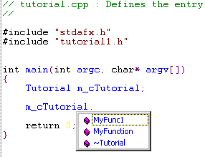Figure 8. Function Dialog Box.

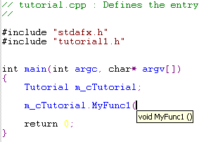Then when a user types a “(“ after a legitimate function, a ToolTip window similar to the one in Figure 9 will appear below the cursor showing the parameters of the function. If the particular function is overloaded, there will be arrows the user can click to show the different definitions.
Figure 9. Tooltip window showing the parameters of the function.

Debugging the application
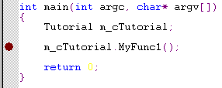 You may have noticed the word breakpoint in several areas while familiarizing yourself with the environment. This item is used in the debugging process. A breakpoint is placed on the current cursor line when the user selects the option from the toolbar, the right-click menu, or the F9 key. Breakpoints appear in the margin as a red dot similar to Figure 10. They can also be disabled, and will appear hollow while this option is selected.
Figure 10. Debug point in margin of code.

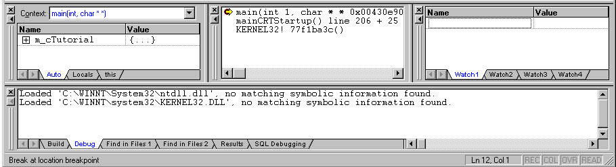To start the debugging process, choose Go from the build menu, or press the F5 key. The program will begin execution. When a breakpoint is reached while the program is running, execution stops. Notice that while debugging is enabled, a new toolbar appears. This toolbar is used in the debugging process. It has options to restart and/or stop debugging, and stop execution. The next section of the toolbar gives the options of stepping over a function, stepping into a function, or running the program until the current cursor location. The next sections of the toolbar list certain windows the user can choose that will improve their turnaround time. These windows (similar to the ones in Figure 11) will list variables, data, and other items the user might wish to observe as their program executes.
Figure 11. Essential Debug Windows.

Another trick to the debugging process is the combination of the output window and the TRACE() function. TRACE allows the user to display certain variables in the output window. This way the program can continue to run while the user debugs, and they can get more accurate knowledge. One of the new features of Visual 6 is its ability to edit-and-continue in the debugging process. Rather than restarting the entire debug process to build a program over a small code change, Visual 6 allows the user to make changes on the fly, and see how they affect the program. Although this is a new technology and has some “undocumented features,” it will prove to help you finish your projects faster than you have before.

Help in the Visual Studio 6 World
Help can be obtained at any time by pressing the F1 key. It is context sensitive, so if the key is pressed over a function, it will display the help information about that function. You can define bookmarks, which will allow you to return to frequently used pages. Another way to obtain helpful information is to use the search button (the one with a set of binoculars and a question mark). There are two types of searches you can perform: an index search, or a query on subsets. The query will probably give more results, but the index might be more accurate. Try the different options and decide which one you think is best.

Conclusion
This concludes the tutorial on the Visual 6 Environment. This tutorial has taught you the initial application, how to build/debug an application and how to obtain help. The tutorial has also covered some of the newer features that will allow you to build a better application faster. It is hoped that this tutorial will help you in the weeks to come and that all the students of EECE 352 will turn into the best programmers this university has seen so far.

