Homework 1
- The C++ Class
- The Linked List Data Structure
- Program Testing, Correctness, and Robustness
- Good Coding Practices
- C++ Review ⇒ List Family Data Structures

Linked List Class

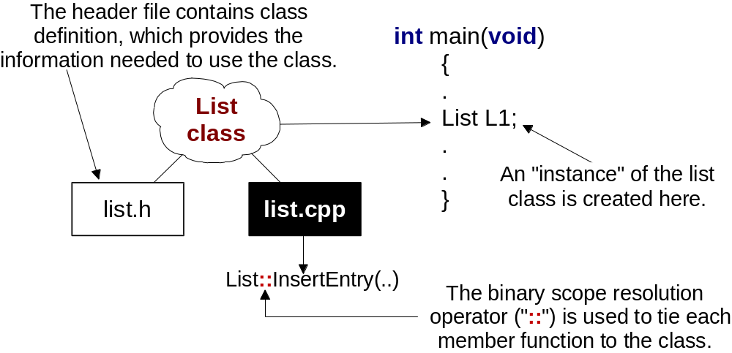

Pointer-Based Structures
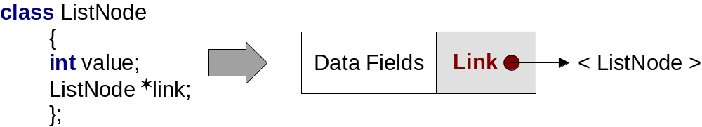
A class (or struct) containing a pointer to itself allows the creation of a list of arbitrary length. The pointer is referred to as a “link” since it links each element to the next. The list is called a linked list.

This is a very common and important structure

Inserting an Element (head)
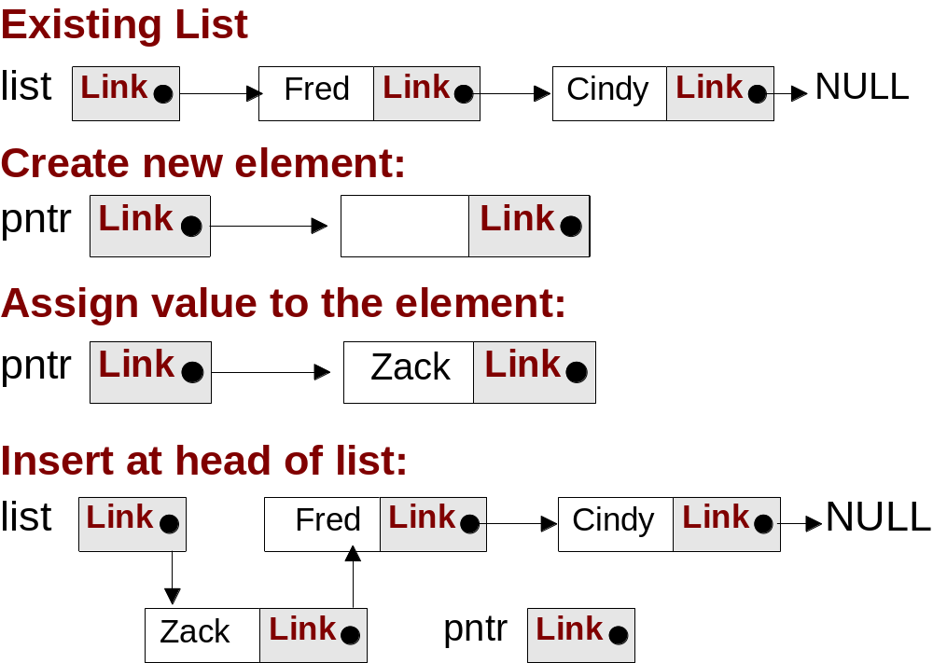

(The list shown stores a character string)

2-Pointer Scheme for Insertion
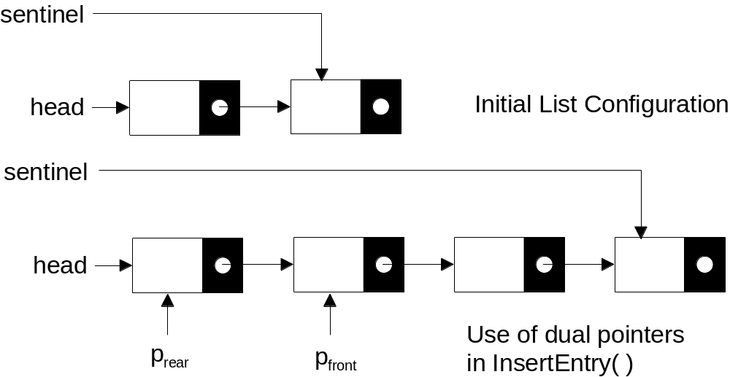

The front pointer is used to locate the first element “after” the insertion point. The new element is then inserted at the head of the list defined by the rear pointer. Use of dummy elements simplifies the initial case.

The Test Program
The test program:
- Read a file of integers and inserted them into the list.
- Compared the count of the file size to the value returned by ListLength( ).
- Wrote the contents of the list to a second file, using GetValue( ) and ListLength.
- Deleted all of the entries in the list, using DeleteEntry() and ListEmpty( )
The file size was 10,000, providing a reasonable amount of “stress” on the program. It was also successfully (but slowly!) tested with a file of 1,000,000 integers

Performance

Version: Total CPU Time:
Debug 12.037 seconds.
Release 4.286 seconds

The compiler optimization was set for “time” rather than size.

Program Robustness
- InsertEntry has no “bad input” in that it is expected to handle any integer value. It checks for successful memory allocation.
- DeleteEntry returns false for an improper index value. It returned appropriate values for several improper values, both positive and negative.
- GetValue can be given an improper index but does not have a way of returning an error since all return values are potentially legal. It returns 0 for an improper index. This can lead to problems.

Program Behavior
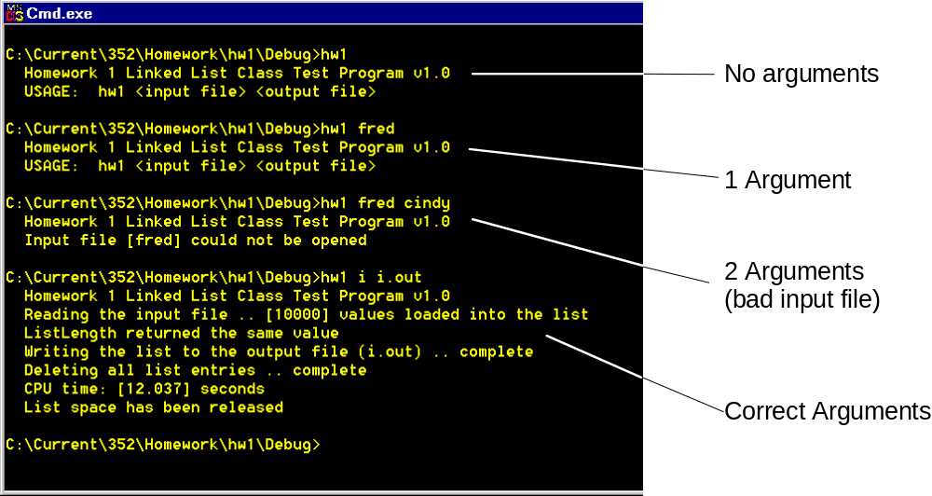

list.h – header and ListNode

//
// The following two lines prevent the header file from being included in any file
// more than once. All of our header files should contain this code.
//
#ifndef LIST_H
#define LIST_H
//
// ListNode definition.
//
class ListNode
{
public:
int value;
ListNode *link;
};

List Class
class List
{
public:
List(void);
~List( );
void InsertEntry(int value); // Insert a new value into the list
// in ascending order.
int GetValue(int index); // Get value at index
bool DeleteEntry(int index); // Delete entry at this location
int ListLength(void); // Return number of entries
bool ListEmpty(void); // Return true if list is empty

private:
ListNode *head;
ListNode *sentinel;
int NumEntries;
};

#endif

Main 1 – (declarations)

#include <iostream>
#include <fstream>
#include <iomanip>
#include <string>
#include <ctime>
#include "list.h"
using namespace std;

void init(int argc, char *argv[ ], fstream &fin, fstream &fout);
int LoadList(List *lp, fstream &fin);
void TimeRequired(float StartTime, string title);

main 2 – Initialization
void main(int argc, char *argv[ ])
{
fstream fin, fout;
float StartTime;
int entries = 0;

StartTime = (float) clock( );
cout << " Homework 1 Linked List Class Test Program v1.0" << endl;
List l;
init(argc, argv, fin, fout);

cout << " Reading the input file .. " << flush;
entries = LoadList(&l, fin);

init

void init(int argc, char *argv[ ], fstream &fin, fstream &fout)
{
if(argc != 3) {
cout << " USAGE: hw1 <input file> <output file>" << endl;
exit(1);
}
fin.open(argv[1], ios::in);
if(!fin) {
cout << " Input file [" << argv[1] << "] could not be opened" << endl;
exit(1);
}
fout.open(argv[2], ios::out);
if(!fout) {
cout << " Output file [" << argv[2] << "] could not be opened" << endl;
exit(1);
}
}

constructor (List)
List::List(void)
{
NumEntries = 0;
// Create extra nodes to streamline the insert operation:
head = new ListNode;
if(!head) {
cout << " Memory allocation error at initialization" << endl;
exit(1);
}
sentinel = new ListNode;
if(!sentinel) {
cout << " Memory allocation error at initialization" << endl;
exit(1);
}
// Create the initial links:
head->link = sentinel; head->value = 0;
sentinel->link = NULL; sentinel->value = 0;
}

LoadList( )
int LoadList(List *lp, fstream &fin)
{
char ch; int entries = 0, errors = 0, value;

for(int i = 0; !fin.eof( ); i++) {
fin >> value; ch = fin.get( );
if(fin.good( ) && ch == '\n') {
lp->InsertEntry(value); entries++;
}
else if(!fin.eof( )) {
errors++;
while(ch != '\n' && !fin.eof( ))
ch = fin.get( );
}
}
if(errors)
return -errors;
else
return entries;
}

main (processing)
if(entries < 0)
cout << "[" << -entries << "] reported loading list" << endl;
else {
cout << "[" << entries << "] values loaded into the list" << endl;
if(entries == l.ListLength())
cout << " ListLength returned the same value" << endl;
else
cout << " [" << entries << "] does not match << endl;
}
cout << " Writing the list to the output file (" << argv[2] << ") .. " << flush;
for(int i = 0; i < l.ListLength( ); i++)
fout << l.GetValue(i) << endl;
cout << "complete" << "\n Deleting all list entries .. " << flush;
while(!l.ListEmpty( ))
l.DeleteEntry(0);
cout << "complete" << endl;
TimeRequired(StartTime, " CPU time");
fin.close( ); fout.close( );
}

TimeRequired( )
//--BEGIN FUNCTION--(TimeRequired)-------------------------------------------------

void TimeRequired(float StartTime, string title)
{
float CPU_time;

CPU_time = (float) clock( ) - StartTime;
if(CPU_time < 1000.0)
cout << title << ": [" << CPU_time << "] milliseconds" << endl;
else
cout << title << ": [" << CPU_time/1000.0 << "] seconds" << endl;
}

//--END FUNCTION--(TimeRequired)----------------------------------------------------

List – InsertEntry( )
//--START FUNCTION--(InsertEntry)------------------------------------------
//
// Insert entries into the list in lexical order (based on the key)
// using the 2-pointer method. p1 is the lead pointer, p2 the lag pointer.
//
void List::InsertEntry(int value)
{
ListNode *p, *p1, *p2;

p2 = head; p1 = p2->link;
sentinel->value = value; // Ensure that the search will terminate
while(value > p1->value) { // Search list for the first entry that
p2 = p1; // is larger than the new value
p1 = p2->link;
}

InsertEntry( ) - 2
p = new ListNode;
if(!p) {
cout << " Memory allocation error (InsertEntry)" << endl;
exit(1);
}
NumEntries++;

p->link = p1; // Use the rear pointer to insert the new
p2->link = p; // entry prior to the one located above.
p->value = value;
}

List – GetValue( )
//--BEGIN FUNCTION--(GetValue)--------------------------------------------------------

int List::GetValue(int index)
{
ListNode *p;
int value = 0;

if(index < NumEntries)
{
p = head->link;
for(int i = 0; i < index; i++)
p = p->link;
value = p->value;
}
return value;
}

//--END FUNCTION--(GetValue)----------------------------------------------------------

List – DeleteEntry( )
//--BEGIN FUNCTION--(DeleteEntry)--------------------------------------------------------

bool List::DeleteEntry(int index)
{
bool status = false;
ListNode *p, *px;

if(NumEntries > index)
{
p = head;
for(int i = 0; i < index; i++)
p = p->link;
px = p->link; p->link = px->link;
delete(px);
NumEntries--;
status = true;
}
return status;
}

List – ListEmpty & ListLength
//--BEGIN FUNCTION--(ListEmpty)--------------------------------------------------------

bool List::ListEmpty(void) {
if(NumEntries == 0)
return true;
else
return false;
}

//--END FUNCTION--(ListEmpty)----------------------------------------------------------

//--BEGIN FUNCTION--(ListLength)--------------------------------------------------------

int List::ListLength(void) {
return NumEntries;
}

//--END FUNCTION--(ListLength)----------------------------------------------------------

List - Destructor
//--START FUNCTION--(~List)---------------------------------------------------------------------------

List::~List( )
{
ListNode *p, *px;

p = head;
while(p != NULL)
{
px = p;
p = p->link;
delete px;
}
cout << " List space has been released" << endl;
}

//--END FUNCTION--(~List)-------------------------------------------------------------------------------

